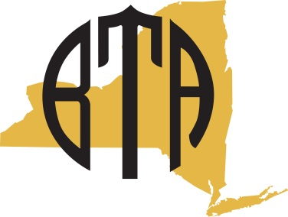

Business Teachers Association of New York State

Slate of Officers Nominations 2014

The following nominations have been accepted by the BTANYS Executive Board:

President Amy Boutet
Amherst High School

President Elect Tara Bellevue
New York City DOE

Recording Secretary Sara Zink
Cattaraugus Little Valley High School

Treasurer Kristen Kelly
West Seneca Central School District

Legislation Director

Public Relations Director Sandy Hoodak
Fairport High School

Region 1 Co-Directors S. Dianne Elmore
Smithtown HS East

Molly Kennedy Henck

Region 5 West Director

Region 5 East Director

Region 7 Director Ed Blasland
Henniger HS

Region 9 Director Francine Martella
All City HS

